**Sink Mobility in WSN Using Multi-Objective Optimization Algorithm**

--------------------------------------------------------------***----------------------------------------------------------------

Chetan Ohri*, Pooja Sharma*, Tushar Thakur Ms. Akshika Jain**

*Department of Information Technology – Assistant Professor-

Krishna Engineering College Krishna Engineering College

**Abstract** – *Wireless sensor network is a tremendously growing field wherein, users can design their sensor based application depending on the application requirements. Sink mobility to collect information in WSN is an interesting area. As a result a variety of mobility models were proposed by research the years. The goals of the work is to provide minimum battery consumption of nodes containing information from the environment by using some multi-objective optimization algorithms. We will apply the algorithm to a set of graphs, the result will demonstrate the benefit of involving sink mobility and they also suggests the desirable moving path of the sink.*

**1. INTRODUCTION**

A wireless sensor network (WSN) is a collection of small, low-power, autonomous devices, known as sensor nodes, that communicate wirelessly with each other to perform distributed sensing tasks. These nodes typically consist of sensors, a processing unit, and a wireless transceiver for communication. They can be deployed in a wide range of environments, such as in agriculture, environmental monitoring, healthcare, and industrial automation.

In a WSN, the sensor nodes can sense different physical or environmental parameters, such as temperature, humidity, pressure, sound, and light, and send the collected data to a central node or a base station for further processing and analysis. The communication between the nodes can be either direct or multi-hop, where the data is forwarded from node to node until it reaches the base station.

Wireless Sensor Networks may consist of many different types of sensors such as seismic, low sampling rate magnetic, thermal, visual, infrared, acoustic and radar. They are able to monitor a wide variety of ambient conditions that include temperature, humidity, vehicular movement, lightning condition, pressure, soil makeup, noise levels, the presence or absence of certain kinds of objects, mechanical stress levels on attached objects, and the current characteristics such as speed, direction and size of an object. WSN application can be classified into following categories: a. Military applications: b. Environmental applications: c. Healthcare applications: d. Home applications: e. Traffic control:

* 1. **Sink Mobility**

Sink mobility refers to the ability of a network sink or base station to move within a wireless sensor network (WSN). In a WSN, sensor nodes are deployed to gather data from the environment and transmit it to the base station, which acts as a sink for the data.

Traditionally, the base station in a WSN is stationary, and the sensor nodes are responsible for transmitting data to the fixed base station. However, in some scenarios, it may be beneficial to have the base station move to different locations to improve network coverage, extend the network lifetime, or enable new sensing capabilities. Sink mobility can be achieved in various ways, such as using a mobile robot or a drone as the base station, or by having multiple base stations that can be moved between different locations. protocol is the first protocol of hierarchical routing which proposed data fusion; it is of milestone significance in clustering routing protocol. Routing strategies and security issues are great research challenge. Nowadays in WSN, numbers of routing protocols have been proposed for WSN but most well-known protocols are hierarchical protocols like LEACH. Hierarchical protocols are defined to reduce energy consumption by aggregating data and to reduce the transmissions to the base station [2].

**2.2 GA**

Genetic algorithms [1] are search and optimization algorithms based on the principles of natural evolution, which were first introduced by john Holland in 1970. Genetic algorithms also implement the optimization strategies by simulating evolution of species through natural selections. Genetic algorithm is generally composed of two processes. First process is selection of individual for the production of next generation and second process is manipulation of the selected individual to form the next generation by crossover and mutation techniques [2]. The selection mechanism determines which individual are chosen for reproduction and how many offspring each selected individual produce. The main principle of selection strategy is the better is an individual; the higher is its chance of being parent.

**3. Sink Mobility in WSN**

In this research work, we propose a hierarchical clustering based data routing protocol for WSNs. The proposed protocol incorporates a Genetic Algorithm (GA) based mobile sink technique. The proposed protocol divides the sensor node region into the optimal number of node clusters. Each cluster is of rectangular size and carries an equal number of member nodes. A rail-based trajectory is built in the sensed region for the sink mobilization. This trajectory passes through at least one boundary of each cluster. Sink moves on the trajectory at a constant velocity. Sink halts at the optimal locations on the trajectory and collects the data packets from the nodes of each cluster. Cluster nodes send their data to sink via the CH node.

The GA process determines the optimal data collection points on the sink movement trajectory for each cluster. A unique chromosome structure including four genes has been proposed for establishing the GA population. The first two genes of each chromosome in the GA population indicate the coordinates of a random sink location while the remaining genes indicate the coordinates of a random cluster head location within a cluster.

Further, a network energy consumption model has been proposed that implements the GA's fitness evaluation operator. The developed GA model converges into a set of optimal data collection points for each cluster. The optimal data collection points consume minimum node energy in data transmission. Hence, the proposed GA based mobile sink approach significantly improves the energy efficiency of WSN.

**4. Energy Efficient Routing Protocol**

Energy efficiency of a network is a significant concern in wireless sensor network (WSN). These days networks are becoming large, so information gathered is becoming even larger, which all consume a great amount of energy resulting in an early death of a node. Therefore, many energy efficient protocols are developed to lessen the power used in data sampling and collection to extend the lifetime of a network. Following are some energy efficient routing protocols:

1. LEACH “Low-Energy Adaptive Clustering Hierarchy” In this type of hierarchical protocol, most of the nodes communicate to cluster heads (C.H) [1] [8]. It consists of two phases: (i). The Setup Phase: in this phase, the clusters are ordered and then Cluster Head(CH) has been selected. The task of CH is to cumulate, wrapping, and forward the information to the base station (Sink) [2]. (ii). The Study State Phase: in the previous state, the nodes and the CH have been organized, but in the second state of “LEACH”, the data is communicated to the base station (Sink). Duration of this phase is longer than the previous state. To minimize the overhead, the duration of this phase has been increased. Each node in the network, contact with the cluster head, and transfer the data to it and after that CH will develop the schedule to transfer the data of each node to base station [8] [2].

2. PEGASIS “Power-Efficient Gathering in Sensor Information Systems” It is a “chain-bases protocol” and an upgrading of the “LEACH”. In “PEGASIS” every node transfers only with a close neighbor to direct and obtain information. It receipts turns communicating to the BS, thus decreasing the quantity of energy consumed per round [9]. The nodes are in this way that a chain should be developed, which can be completed by the sensor nodes along with using an algorithm. On the other hand, the BS can compute this chain and transmission of it to all the sensor nodes. [10]To develop the chain, it is expected that all nodes have universal information of the system and that a greedy algorithm is engaged. Thus, the structure of the chain will begin from the remote node to the nearer node. If a node expires, the chain is rebuilt in the similar method to avoid the lifeless node [11].

**5. Existing Approach**

**5.1 Energy Radio model**

Currently, there is a great deal of research in the area of low-energy radios. Different assumptions about the radio characteristics, including energy dissipation in the transmit and receive modes, will change the advantages of different protocols. In our work, we assume a simple model where the radio dissipates Eelec=50 nJ/bit to run the transmitter or receiver circuitry and €amp=100 pJ/bit/m2 for the transmit amplifier to achieve an acceptable Eb /No .These parameters are slightly better than the current state-of-the-art in radio design. We also assume an r2 energy loss due to channel transmission. Thus, to transmit a k-bit message a distance d using our radio model, the radio expands:

ETx(k,d)=ETx-elec(k)+ETX-amp(k,d) ETx(k,d)=Eelec*k+€amp*k*d2 (1)

and to receive this message, the radio expands:

ERx(k)=ERx-elec(k)

ERx(k)=Eelec*k (2)

For these parameter values, receiving a message is not a low cost operation; the protocols should thus try to minimize not only the transmit distances but also the number of transmit and receive operations for each message. We make the assumption that the radio channel is symmetric such that the energy required to transmit a message from node A to node B is the same as the energy required to transmit a message from node B to node A for a given SNR. For our experiments, we also assume that all sensors are sensing the environment at a fixed rate and thus always have data to send to the end-user. For future versions of our protocol, we will implement an ”event-driven” simulation, where sensors only transmit data if some event occurs in the environment.

**6. Methodology**

* 1. **Requirement Analysis**

Conduct a thorough risk assessment to identify potential challenges in sink mobility implementation, such as network congestion, sink movement synchronization, and communication overhead. Perform a comparative analysis of different GA variants to select the most suitable algorithm for the route optimization process based on convergence speed and solution quality.

**6.2 System Design**

Apply modular design principles to ensure flexibility and extensibility, allowing for easy integration of future enhancements, such as incorporating additional optimization algorithms or supporting heterogeneous sensor nodes. Utilize object-oriented design patterns, such as the observer pattern, to decouple system components and facilitate future maintenance and upgrades. Design the user interface, considering usability and visualization requirements.

**6.3 Implementation**

Implement efficient data structures, such as graphs and priority queues, to enable quick route evaluation and selection during the GA-based optimization process. Utilize MATLAB's parallel computing capabilities to leverage multi-core processors and expedite the route optimization process for large-scale WSNs.

Implement the user interface components and integrate them with the system modules.

**6.4 Testing and Evaluation**

Conduct stress testing by simulating various scenarios, such as sudden changes in sensor node density, sink node failures, or communication disruptions, to assess the system's robustness and resilience. Perform statistical analysis on simulation results to quantify the improvements achieved through sink mobility, such as increased network lifetime, reduced energy consumption, and enhanced data collection efficiency.

1. **Result**

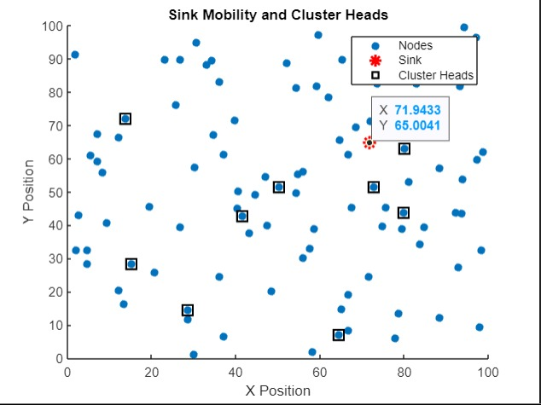

Fig 6.1 Forming cluster heads

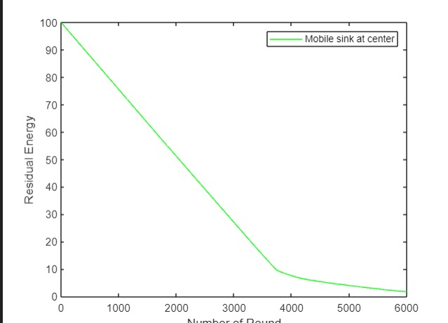

Fig 6.2 Mobile sink at centre

**8. Conclusion**

**5.1 Performance Evaluation**

When designing protocol architectures for wireless sensor networks, it is important to consider the function of the application, the need for ease of deployment, and the severe energy constraints of the nodes. These features led us to design LEACH-C, a protocol architecture where computation is performed locally to reduce the amount of transmitted data, network configuration and operation is done using local control, and media access control (MAC) and routing protocols enable low-energy networking. Results from our experiments show that LEACH-C provides the high performance needed under the tight constraints of the wireless channel. After using GA we found that the nodes dying at certain rounds in LEACH are now performing far batter since the energy is optimizing.

**9. References**

[1]FengS. et al.Unknown hostile environment-oriented autonomous WSN deployment using a mobile robotJ. Netw. Comput. Appl ,2021.

[2]AgarwalV. et al.A survey on path planning techniques for mobile sink in IoT-enabled wireless sensor networks Wirel. Pers. Commun ,2021

[3]NguyenL. et al.Mobility based network lifetime in wireless sensor networks: A review Comput. Netw ,2020.

[4] Z. Fei, B. Li, S. Yang, C. Xing, H. Chen and L. Hanzo,  "A Survey of Multi-Objective Optimization in Wireless Sensor Networks: Metrics, Algorithms, and Open Problems," in IEEE Communications Surveys & Tutorials, vol. 19, no. 1, 2019

[5] V. L. Quintero, C. Estevez, M. E. Orchard and A. Pérez, "Improvements of Energy-Efficient Techniques in WSNs: AMAC-Protocol Approach," in IEEE Communications Surveys & Tutorials, vol. 21, no. 2, 2015

[6] W. B. Heinzelman, A. P. Chandrakasan, and H. Balakrishnan, “An application-specific protocol architecture for wireless microsensor networks,” IEEE Transactions on wireless communications, vol. 1, no. 4, pp. 660–670, 2012.

[7] W. B. Heinzelman, A. P. Chandrakasan, and H. Balakrishnan, “An application-specific protocol architecture for wireless microsensor networks,” IEEE Transactions on wireless communications, vol. 1, no. 4, pp. 660–670, 2012.

[8] O. Younis and S. Fahmy, “Heed: a hybrid, energy-efficient, distributed clustering approach for ad hoc sensor networks,” IEEE Transactions on mobile computing, vol. 3, no. 4, pp. 366–379, 2010.

[9] V. Mhatre and C. Rosenberg, “Homogeneous vs heterogeneous clustered sensor networks: a comparative study,” in Communications, 2004 IEEE International Conference on, vol. 6, pp. 3646–3651, IEEE, 2010.

[10]W. R. Heinzelman, A. Chandrakasan and H. Balakrishnan, "Energy-efficient communication protocol for wireless microsensor networks," Proceedings of the 33rd Annual Hawaii International Conference on System Sciences, Maui, HI, USA, 2000, pp. 10 pp. vol.2-, doi: 10.1109/HICSS.2000.926982.

[11]K. F. Man, K. S. Tang and S. Kwong, "Genetic algorithms: concepts and applications [in engineering design]," in IEEE Transactions on Industrial Electronics, vol. 43, no. 5, pp. 519-534, Oct. 1996, doi: 10.1109/41.538609.